Abiding In The Vine vs. Burnout in Ministry
January 4, 2017
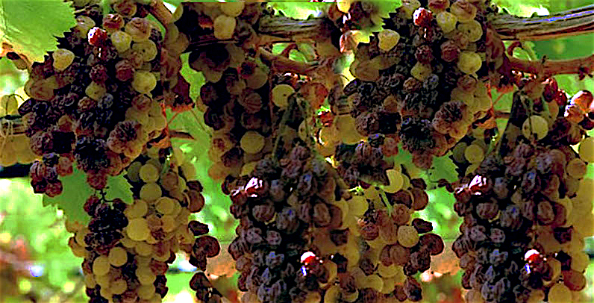
Well, my dear Heartdwelling family, with the increase in anointing and expanded vision, expanded mission, that some of us are experiencing, we are coming into things that we only dreamed about. And they are so exciting that we can't wait to engage them and do some these wonderful things that He's assigned to us.

And herein lies the danger - that we begin to seek the power gifts and the feeling of being used of God for His Kingdom and lose sight of the precious privilege of our relationship with Him and being so very close to Him.

The Lord loves using those the rest of the world has discarded, even as He proclaimed, “The stone the builders rejected has become the cornerstone.” Many Heartdwellers have lived a life of rejection in the church community or even in the world because they were a little different. And now the Lord has taken us and given us some of the premium gifts to be used in ministry that have a visible impact on the world and the Kingdom of God.

Of course, we know the honor and power and glory all go to Him, but we can't help but notice that these gifts are also affecting others in a wonderful way. That can lead to a sense of accomplishment and well-being that "finally my life has meaning and purpose!"

But we should not miss the significance of the atonement for our sins on the Cross and that none of us has any more value than the Blood that was shed on our behalf by the Son of God.

So what is our net worth? Is it not the very Blood of God? But we must remember that even with the wonderful gifts, we cannot increase our value one iota.

But being very hungry to be used, to find purpose, to have a mission, to be doing something for God can become a focal point in our lives - rather than keeping our focus on the precious relationship we have with our sweet Jesus. We can become excited when people begin to recognize our gifts and line up, back to back, to receive ministry.

Signs that our focus is shifting begin with having less and less time for prayer. Then they progress to emotional/mental/physical exhaustion and keep going until they've hit finally burnout, because we are so overwhelmed with work for the Kingdom.

Once we begin to become exhausted, we are prone to making errors in discernment. Life has become so exciting and rich with opportunity to help others, we can lose sight of the fact that we’ve lost sight of the Lord and His tender and sweet embrace. I have found that I need substantial time with Him in worship. Ministry is only the tip of the iceberg; my relationship must be the hidden 80% that is below the water line and seen by no-one.

So, here is where we need to apply violence to our own ambitious will and keep our relationship and our love for Jesus fresh and the primary focus. Some gifts are so spectacular and unusual that once they're given and we exercise them, we become distracted away from the person of Jesus, because of our long-standing need for accomplishment and self-worth.

And under this guise we can think that we are doing more and more for the Lord - and we may very well be. But the most important thing we can do is to abide in the Vine, with worship and adoration in Spirit and in Truth. When we cease to abide in the vine, our fruit ceases as well.

Remain in Me, and I will remain in you. Just as no branch can bear fruit by itself unless it remains in the vine, neither can you bear fruit unless you remain in Me. I am the vine and you are the branches. The one who remains in Me, and I in him, will bear much fruit. For apart from Me you can do nothing. If anyone does not remain in Me, he is like a branch that is thrown away and withers. John 15:4-6

The other danger that I believe we have always faced is changing the focus from seeking Jesus and His sweet company to seeking the anointing and giftings. My fear regarding this is the severe indictment against ministers, “Many will say to Me on that day, ‘Lord, Lord, did we not prophesy in Your name, and in Your name drive out demons and perform many miracles?’ Then I will tell them plainly, ‘I never knew you; depart from Me, you workers of lawlessness.’…” Matt 7:22-23

I would love to have more understanding of why He calls them 'workers of lawlessness,' but from my experience looking back upon many years, it seems that the ones who feel justified by what they are doing for God cause trouble for the little ones who only find their joy in their intimate relationship with the Lord. These little ones take on more of His character in humility, quietness and gentleness in conversation. They are the ones who listen to others and have very little to say. Often they are looked upon as nothings, where the more vocal and aggressive ministers seem to be shining stars.

So, what is the solution? Pray for the grace to see that the most precious thing we can do in our day is to be with Him in worship, in spirit and in truth. And that all ministry is secondary to that mandate to worship Him, and His gentle character is formed in us the longer we linger with Him.

I kind of ran out of things to say, so I said, Lord, do you have something to add?

Jesus began, “It is always My joy to give My Bride the better gifts. But knowing the human heart, I must brace Myself for her fascination with them and the likelihood that she will be drawn away from Me by them. And so it goes with the human heart…fickle as it is. But sooner or later she tires of even the gifts and longs to return to My waiting arms. That’s when I catch her up and scoop her back into My bosom.

"Oh dear ones, I expect you to be distracted by these wonderful gifts you’ve never even imagined having. How I love to surprise you and flood you with joy over the healings and deliverances that come about as a result of them.

"But these gifts are the fruit of abiding in the Vine. And all that flows from the branches - the bark, stems and roots - is necessary to produce the sweet plump grapes.

"Imagine a large cluster of grapes just coming into its fulness but the weight of the fruit causes the stem to snap, not all the way but in part. Now the cluster is without the full benefit of nourishment from the Vine; its nourishment is diminished. The grapes which were plump, but still unripened, and a little sour, are now beginning to shrivel and eventually, after a very few days, the grapes no longer resemble grapes but raisins hanging from a limp vine.

“So it is with you, My Brides. Unless you maintain the healthy connection with Me, your grapes will be sour and begin to wither. You cannot maintain that level of giving without receiving first. I know the temptation to run about ministering to others is great, especially with new gifts. But you will only run that far and hot without deepening your connection with Me, for a very short time.

“Please, worship and linger in My presence first. Rather than being anxious to set to work, be anxious to stay longer until you know I am calling you to begin your day. Cling to Me, My Bride, Cling to Me and find more joy in My presence than healing all the ills of the world.

"You cannot be led astray by this heart attitude. But you can be easily manipulated into fatigue and burnout by being too excited to get started in your day…to go on the quest so to speak, to take up the challenge and do battle victorious over your external foes. But remember, you are your own worst enemy. Satan reads you like a book, so do his demons, and they know exactly how to make you bolt out of prayer. But if you are resisting jumping into action, they have a far more difficult time.

"Yet it is not only about the enemy, My Beloved ones. It is also about Me. I want to be wanted more than any gift I can give you. I want to be your everything. I am hurt when you think of other lovers when we are together. I long for the Marys, who seek only to sit at My feet and drink Me in.

"Don’t worry, I will let you know when it is time for action and 'you will go out with joy And be led forth with peace; The mountains and the hills will break forth into shouts of joy before you, And all the trees of the field will clap their hands. Isaiah 55:12.

